Relational Databases with MySQL Week 4 Coding Assignment

**Points possible:** 70

|  |  |  |
| --- | --- | --- |
| Category | Criteria | % of Grade |
| Functionality | Does the code work? | 25 |
| Organization | Is the code clean and organized? Proper use of white space, syntax, and consistency are utilized. Names and comments are concise and clear. | 25 |
| Creativity | Student solved the problems presented in the assignment using creativity and out of the box thinking. | 25 |
| Completeness | All requirements of the assignment are complete. | 25 |

**Instructions:** Using a text editor of your choice, write the queries that accomplishes the objectives listed below. Take screenshots of the queries and results and paste them in this document where instructed below. Create a new repository on GitHub for this week’s assignments and push this document, with your Java project code, to the repository. Add the URL for this week’s repository to this document where instructed and submit this document to your instructor when complete.

**Coding Steps:**

Write 5 stored procedures for the employees database.

Write a description of what each stored procedure does and how to use it.

Procedures should use constructs you learned about from your research assignment and be more than just queries.

**Screenshots:**

1. Procedure to concatenate the first and last name of an employee. Call CombineFirstLastName procedure to save time coding and retrieving results that require the first and last names of employees.

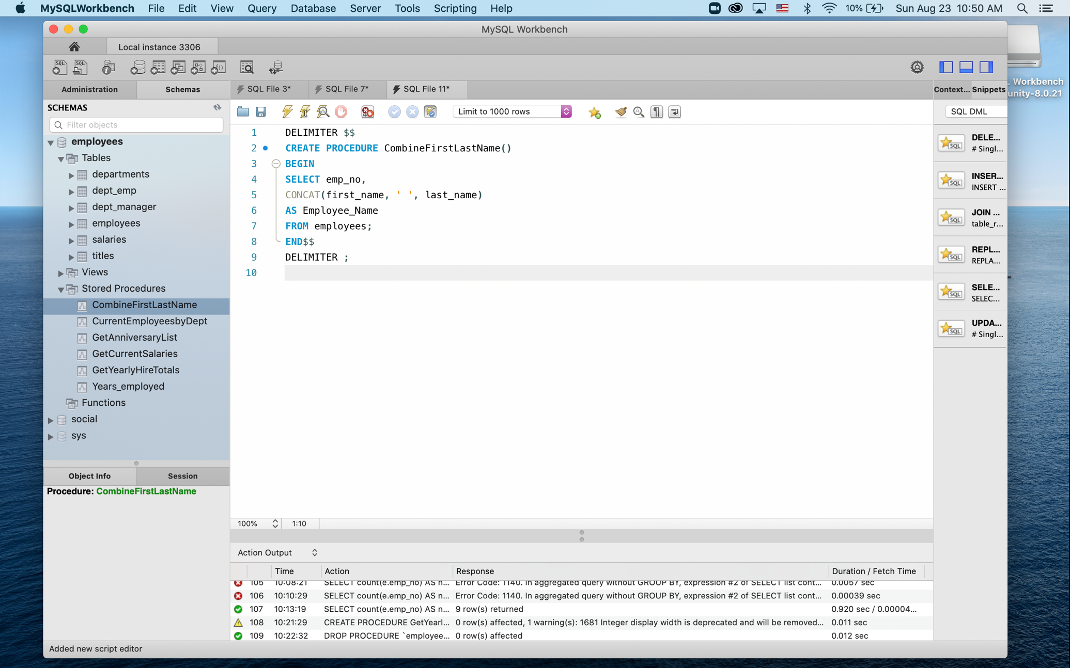

1. Get the current salaries of employees. CombineFirstLastName retrieves a listing of salaries for current employees in their current positions.

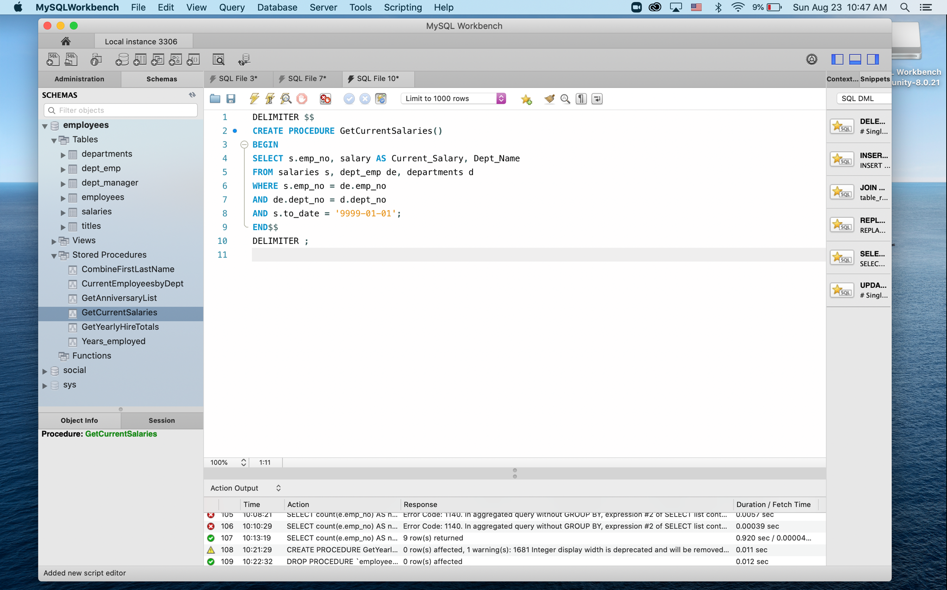

1. Get current employees by department. Call CurrentEmployeesbyDept() stored procedure and enter one of the department names from the departments table to identify the current employees in a specified employees.

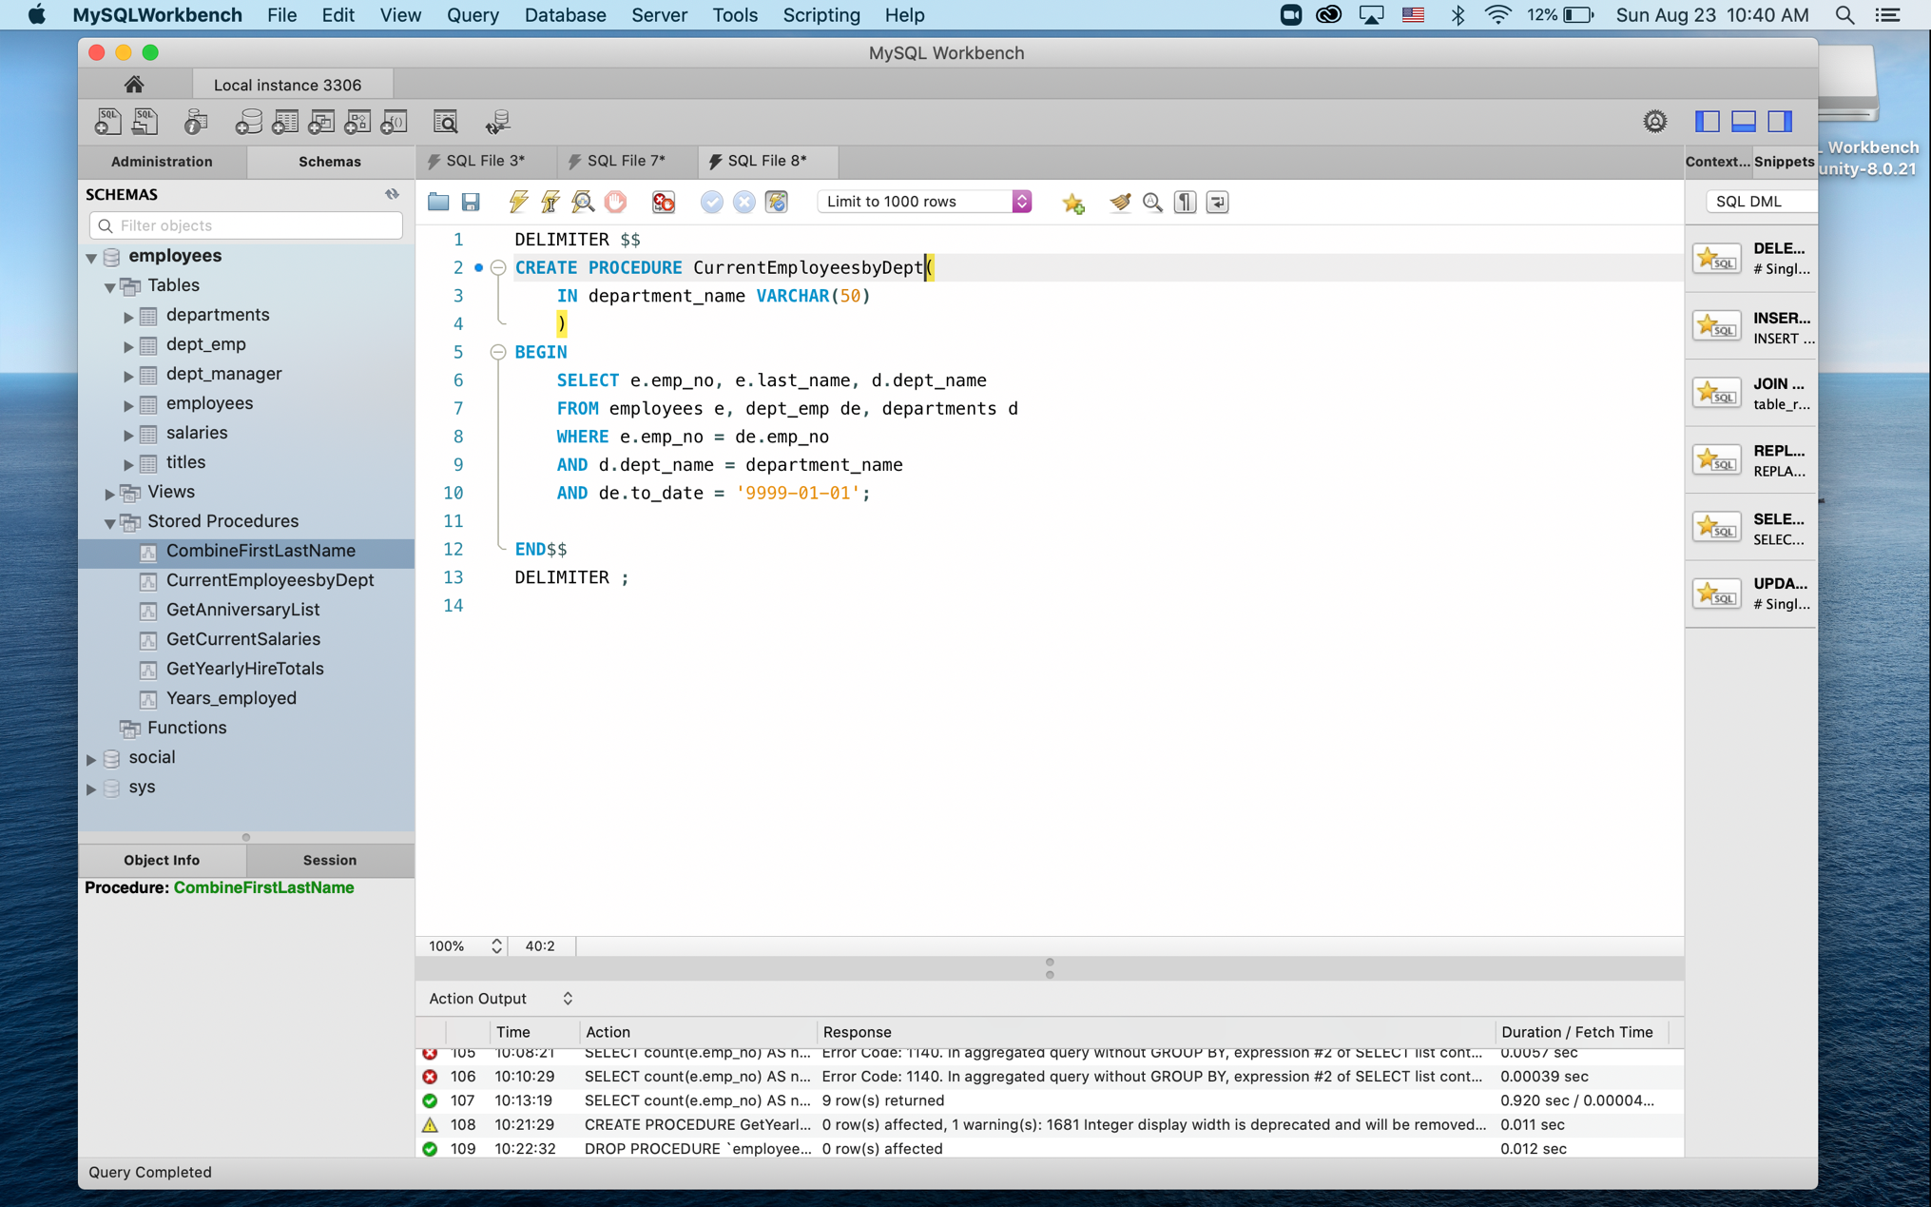

1. Get a list of employees hire date to send card during anniversary month. Enter number of month in the GetAnniversaryList procedure to retrieve a list of employees hired in a specific month.

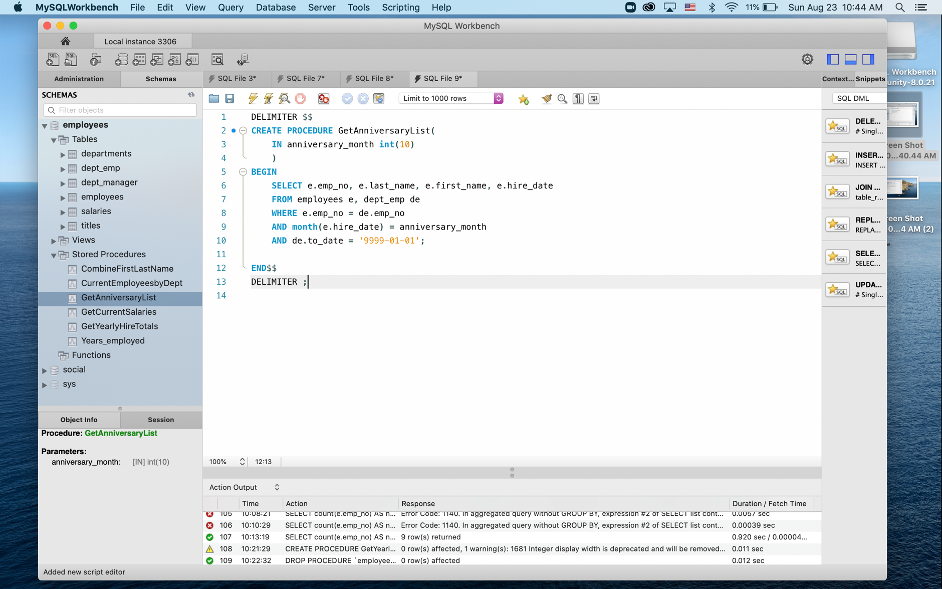

1. Count of employees hired by each department for a specified year. Use GetYearlyHireTotal and pass through a specific year to see each departments hire counts.

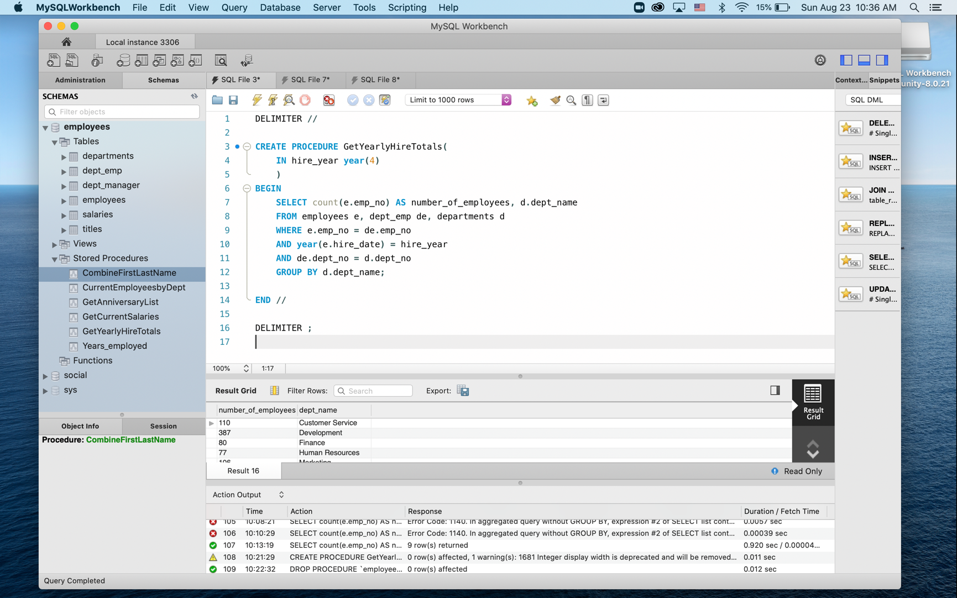

**URL to GitHub Repository:**